229050574

CO2104

HIGH FIDELITY DESIGN PORTFOLIO

DUE DATE: 12/05/2025

INTRODUCTION

This high fidelity design portfolio presents my user focused web application building on my medium fidelity wireframes developed on pencil in HW1. I will be developing a ‘weekend city break’ desktop website centred around the Norwich Market. This will be made for tourists and any casual visitors in helping them explore the market to its fullest. I want to create a user friendly website that provides personalisation to the visitor by allowing users to create their own accounts and be able to favourite stalls. Motivation behind designing this website comes from the need to simplify planning this will help visitors discover unique stalls that they might miss, help visitors create a plan of stalls they want to visit saving them the time of looking around and searching on foot. This will help support stall owners by improving the stalls visibility. Key user requirements needed include a simple login system, being able to save favourite stalls, simple and smooth UI and smooth navigation throughout the system all which will help to create an enjoyable personal experience.

PROTOTYPE FUNCTIONALITY

Using the ‘T-Shaped/Vertical’ approach I will be developing a prototype focused on one advanced feature that will be developed from cw1-medium fidelity prototype, and one basic feature. Other features of my website will be visually present but with placeholder content. The basic feature I will be developing will be a ‘login/sign up’ system that enables users to create accounts, log in and view a profile management page to update details. The log-in will be hardcoded for the demo. This feature is a fundamental element that enables user interaction and customisation across the website.

My advanced feature from cw1 that I will be focusing on is a ‘Add to favourites’ system. This will allow users to save a market stall that appeals to them that they can return to later. Users should be able to do this simply by clicking the heart icon on a stall, the saved stalls are shown on an individual Favourites page where a user will be able to browse their saved stalls. In addition the user will have full control over their saved stalls as they can remove stalls from the favourites whenever they want. This feature relates to user requirements such as helping user plan a visit and user personalisation. It also enhances the user engagement by providing a sense of control.

Finally I will be developing a ‘Dark Mode’ toggle which was not in my original cw1 design. The goal of this feature is to increase the user experience and comfort/accessibility, especially in low light environments to decrease the eye strain and improve viewing. Dark mode will use JavaScript and CSS to apply a dark colour scheme when its toggled. Having a dark mode will also add to the users customisation/personalisation as they have control over viewing in light mode or dark mode.

BACKGROUND TECHNOLOGIES

This prototype was developed without the need for external UI frameworks or JavaScript libraries. Main tool used was simple JavaScript and CSS. To enhance the visual design I used icons, images and font from online sources mentioned in the sources text file. All layouts, styling and interactivity was done manually with no need of any external libraries. This way it provided me full creative control while maintaining a high fidelity prototype.

WALKTHROUGH IN FORM OF ANNOTATED SCREENSHOTS

Screenshot 1:

Function of webpage: Allow user to log in to existing account or create a new account, the gateway to enter the website.

Create one – link, redirect user to register a new account

Clear login button, allow user to be redirected to homepage if credentials exist and are correct

Centred box including field for username and password

(create account page and profile page look similar like this)

Navigation – Clicking log in will redirect user to the dashboard, and create an account will redirect user to new account page.

Accessibility – username and password field labelled properly, log in button clearly labelled.

Screenshot 2:

Function of webpage: homepage acts as dashboard users see upon logging in where users can browse all stalls at the Norwich Market.

Icons in header provide visual placeholder except Moon(Dark mode), ID(Profile Management) and Door(Sign Out)

Search bar allow user to search by name

Buttons in stall list include visual placeholders for filter, Sort and map and one functional button ‘heart’ which is favourites page

Simulated prototype google reviews to simulate user reviews

Each stall shown as a card showing image, name, heart icon (Add to favourites) and a share icon placeholder

Navigation – Click heart icon to add to favourites list shown a visual cue, Header icon; dark mode clicking turns page into dark mode, Profile Management button redirects user to new page to update account, Sign-out button redirects user back to the login.

Accessibility – All icons have hover text, webpage is responsive and adapts if you change size of webpage.

Screenshot 3:

Function of webpage: shows the favourite page with a stall added to favourites/ empty page if no stalls are added.

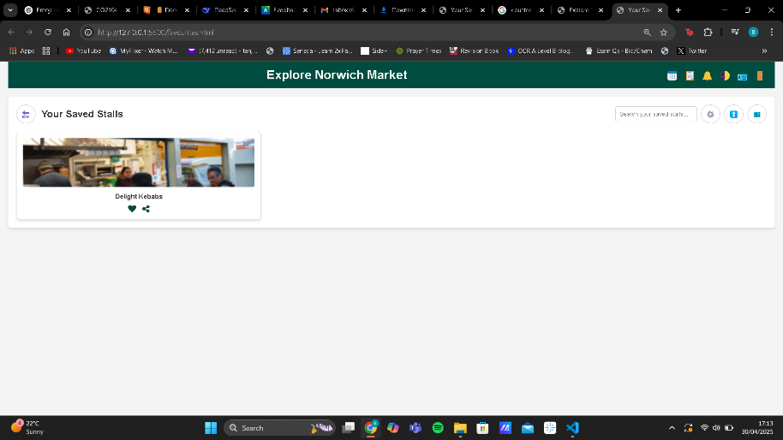

Saved stall card showing saved stall with image, name, heart icon and share icon

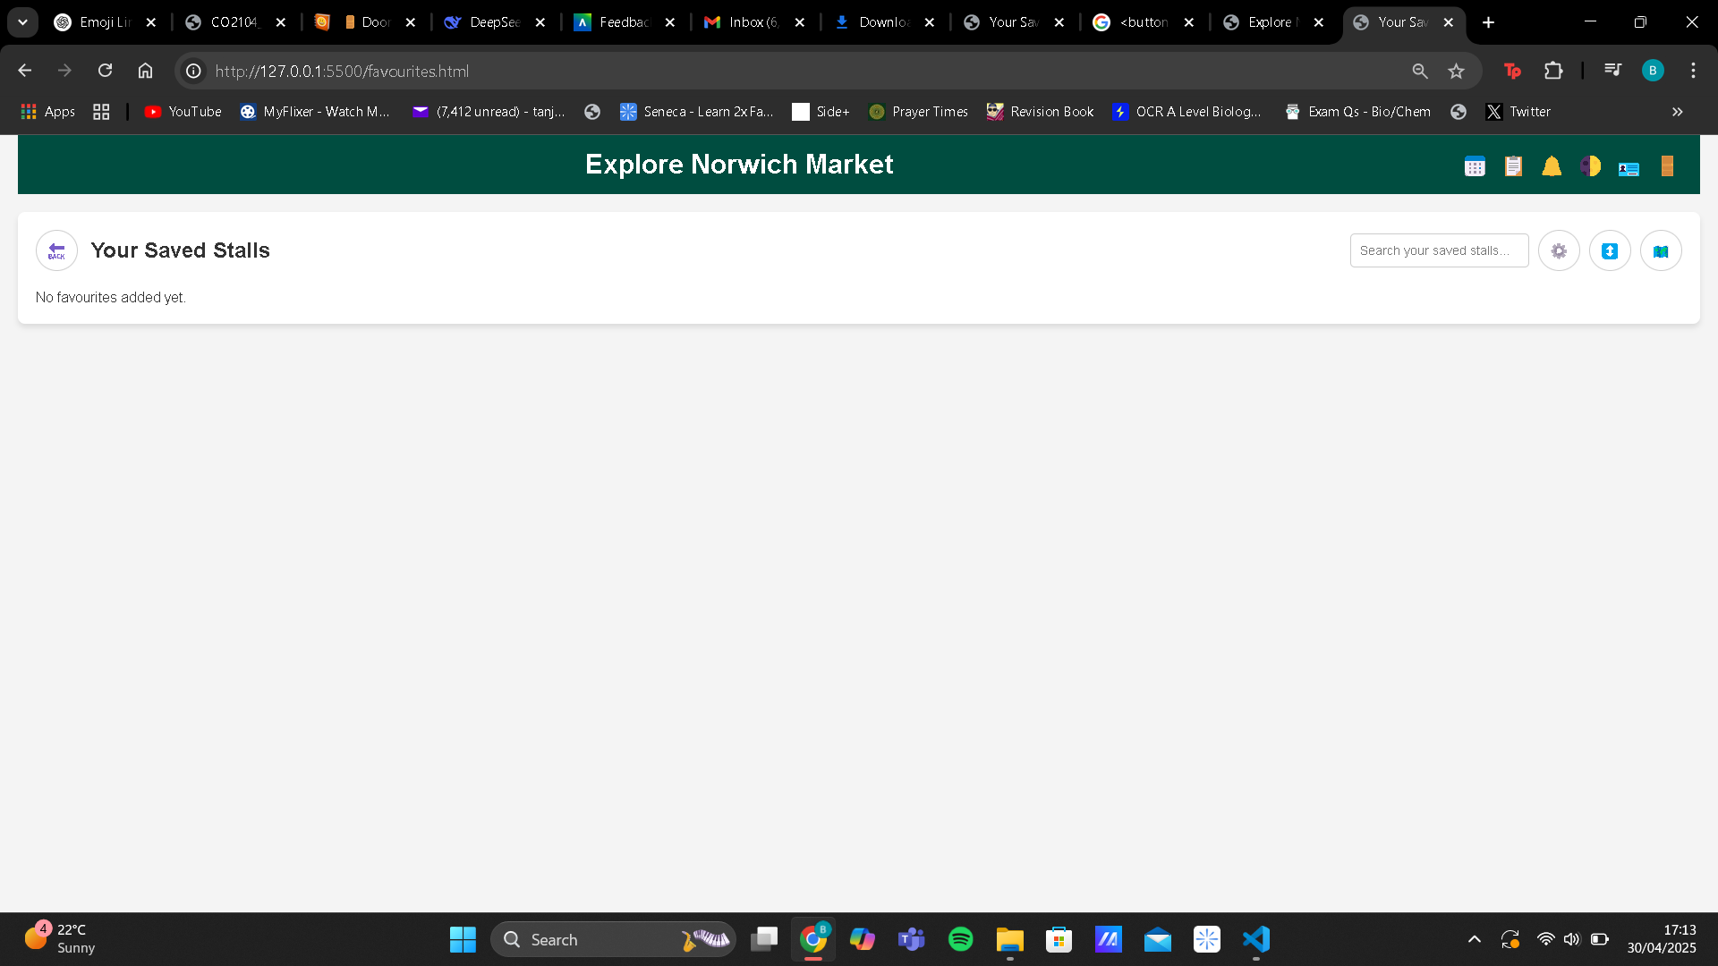

Interactive heart icon allowing user to remove from favourites

No stalls saved show a message

Back to market button so users can go back to stall view

Navigation – user can click on heart to unsave a stall visual cue provided. Clicking on the back button will take the users back to market view.

Accesibility – clear text provided when there is no saved stalls.

HEURISTIC EVALUATION AND USABILITY TESTING RESULTS

Using Nielsen’s 10 heuristics I conducted a heuristics evaluation to determine the usability of my high fidelity prototype. 5 users took part in my testing 2 peers, 2 university students from a different course and 1 family member. This allowed me to see how real users would engage with the website and help me identify the strengths and usability issues leading to improvements reflecting real user needs.

The evaluation form that was sent to my 5 users is included called HeuristicEvalautionForm.docx showing all usability tests and the severity scale used to score each heuristic

A summary of the users evaluations is shown below

|  |  |  |
| --- | --- | --- |
| Heuristic | Positives | Issues |
| Visibility of system status | Hover effects on icon/stalls, adding to favourites | What happens when you click share? |
| Match between system & real world | Majority icons used are familiar (heart/share) | Sign out and profile icon aren’t that specific |
| Consistency & standards | UI was consistent across the pages | Header layout is too cluttered too many icons |
| User control & freedom | Favourites can be added and removed | No issues identified |
| Error prevention | Little to none errors present | More input validation |
| Recognition rather than recall | Self-explanatory icons and clear layout for the stalls | Profile page lacking detail seems similar to the login page |
| Flexibility & efficiency of use | Basic and advanced feature were quick and easy to complete | Profile management and sign out could be in a separate section |
| Aesthetic & minimalist design | Clean layout, visually appealing aesthetic and simple colours used (dark mode was more appealing) | Cluttered header – recurring issue |
| Ability to identify & recover from errors | Most users navigated through website without any assistance | Certain buttons could use a message to let user know it’s in development |
| Help & documentation | Most actions were self-explanatory | Share icon lacks details of what share options are available |

FEEDBACK AND DISCUSSION

The feedback provided by my test users on the heuristic evaluation and usability testing influenced the improvements on my prototype. Every user mentioned uncertainty about the share icon especially how it would appear and what share options would be available. In response to this I implemented a prototype share popup that appears when a user clicks share with all share options. Improving the system visibility.

Majority users commented on how the header felt to cluttered to fix this I implemented a side panel where header icons not relating (sign out and profile management) would be found, clearing up the interface and improving the navigation.

All users mentioned how the log-in page was basic and not inviting along with the profile management page lacking a unique style for a profile page and very simple layout. In order to fix these issues I improved the layout and CSS for both pages by including photos and welcome message in log-in page and a better structure and images for profile page, making them more visually appealing and being consistent with the rest of the website.

After

Before

Finally a couple users mentioned how the filter and sort icon even if in development lacked a message when clicked so to address this I added a html alert to these buttons so when user clicks it they get informed that this button is under development.

All of these updates made to my prototype show how the users feedback helped to improve the usability of my prototype.

CONCLUSION

In this project I created a high-fidelity prototype for a ‘Weekend City Break’ focusing on the Norwich market. Made to support users in exploring and planning their visit. This prototype successfully implemented the core features planned; a user log-in/create account, profile management and a favourite system. Along with these features there was an additional improvement in the form of dark mode. Based on the feedback from the user evaluation I implemented a prototype share function alongside this I made more visual enhancements. To progress this prototype into becoming the starting point for the final development all placeholder pages and prototype interactions would need to be finished. A backend database would be required to handle user details and the stall content. Additionally I would need to integrate third-party APIs such as google maps and google reviews which would improve the navigation and real-time information for the stalls. Finally to get this one step closer to a final development you would need to ensure the scalability of this website on different devices and do further testing.